STATEMENT OF COOPERATION BETWEEN
NATIONAL COUNCIL OF ARCHITECTURAL REGISTRATION BOARDS (NCARB)
ANO

CONSELHO DE ARQUITETURA E URBANISMO DO BRASIL (CAU/BR)

Parties

The National Council of Architectural Registration Boards (NCARB) has as its mission to "protect the public health, safety, and welfare by leading the regulation of the practice of architecture through the development and application of standards for licensure and credentialing of architects". lt represents the architectural licensing boards of the 50 states, the District of Columbia, Guam, Puerto Rico, and the U.S. Virgin Islands.

The Conselho de Arquitetura e Urbanismo do Brasil (CAU/BR), (The Council of Architecture and Urbanism in Brazil) was created in 2010 to regulate the practice of architecture and Urbanism in the country. CAU/BR's purpose is to "orient, discipline and supervise the praccice of the profession of architecture and urbanism, ensure the faithful observance of the principles of ethics and discipline in the class throughout the country, as well as strive for improving the practice of ardútecture and urbanism ".

WHEREAS, both parties are empowered to facilitate the regulation of the profession of architecture in their respeccive countries and share the goal of licensing architects to offer professional services within their jurisdictions under circumstances that secure and protect the health, safety and welfare of the public;

WHEREAS, both parties are interested in promoting mutual cooperation in order to improve the regulation of architectural practice in both countries;

WHEREAS, both parcies recognize that differences among the standards and processes for licensing/ registering architects in the USA and Brazil must be acknowledged and respected;

WHEREAS, NC.r\RB has a long history of developing standards for architectural education, experience, and exarnination for inicial licensure as well as continuing education standards for license renewal, while on the counterpart, CAU/BR has already created an effective nacional system of monitoring various aspects of architectural professional practice in the country;

THEREFORE, both parties agree to cooperate in the field of professional standards to support registration, regulation, public protection, and other related areas of mutual interest. And agree to:

- Exchange information on procedures, standards, and best practices concerning architectural regulation, parcicularly regarding NCARBs' programs such as the NCARB Ed1,catio11 Standard, , the Intern Development Program, the Architect Registration Exami11atio11\ Continuing Education, Mode/ Law, and Rufes of Cond11ct and the

CAU/BR's system of monitoring architectural professional practice in Brazil, such as CA U 's SysteJJJ of lnfor111atio11 a11d Comnnmication (SICCA U), including demographic data, documents, papers and surveys;
- Facilita te the representa tives of both countries to observe each other's activities in order to learn from both experiences.

ln the spirit of cooperation and collaboration, the unders igned hereby agrees to the principles contained within this Statement of Cooperation and confirms a willingness to share professional expertise in support of the profession of Architec ture.

Dale McK.inney, FAIA, N-;' l
g(
President rR

NCARB
1801 K Street 1'TW, Suite 700K Washington, DC 20006
United States of America

Signed: 12 December 2014
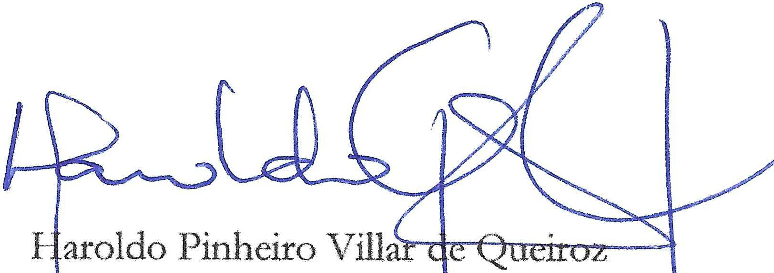
P esident

C U/BR
S S Qd 02 Bl. C
Ed. Serra Dourada, Salas 401/409 70.711-903 Brasilia/DF
Brazil

Witnessed by:

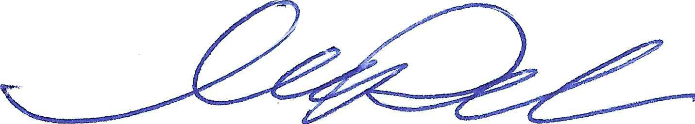

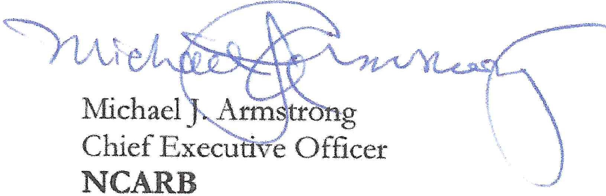
1801 K Street NW, Suite 700K Washington, DC 20006
United States of America
Fernando Diniz Moreira Federal Counselor CAU/BR
ses Qd 02 B1. e
Ed. Serra Dourada, Salas 401/409 70.711-903 Brasilia/DF
Brazil

Stephen Nutt, AIA, NCARB, CAE Sr. Architect / Advisor to the CEO NCARB
1801 K Street NW, Suite 700K Washington, DC 20006
United States of America

